Monolingual Dictionary

What is Monolingual Dictionary
# Source: AI Source: Provided by: [Data Path: Persons Table -> ID Column: 1, Name_En Column: Motasem Essam] -> From: [Chatgpt (GPT-4-turbo)] on [7/29/2025]
A Monolingual Dictionary provides definitions, explanations, and information in the same language as the headwords (entries). It does not involve translation between languages but rather focuses on explaining vocabulary using the target language itself.

🔹 Key Features of a Monolingual Dictionary
# Source: AI Source: Provided by: [Data Path: Persons Table -> ID Column: 1, Name_En Column: Motasem Essam] -> From: [Chatgpt (GPT-4-turbo)] on [7/29/2025]
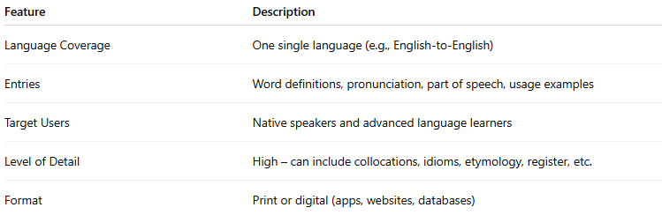
Feature | Description
Language Coverage | One single language (e.g., English-to-English)
Entries | Word definitions, pronunciation, part of speech, usage examples
Target Users | Native speakers and advanced language learners
Level of Detail | High – can include collocations, idioms, etymology, register, etc.
Format | Print or digital (apps, websites, databases)

🔹 Examples of Monolingual Dictionaries
# Source: AI Source: Provided by: [Data Path: Persons Table -> ID Column: 1, Name_En Column: Motasem Essam] -> From: [Chatgpt (GPT-4-turbo)] on [7/29/2025]
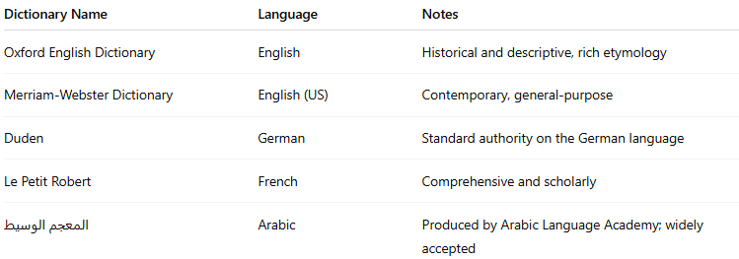
Dictionary Name | Language | Notes
Oxford English Dictionary | English | Historical and descriptive, rich etymology
Merriam-Webster Dictionary | English (US) | Contemporary, general-purpose
Duden | German | Standard authority on the German language
Le Petit Robert | French | Comprehensive and scholarly
المعجم الوسيط | Arabic | Produced by Arabic Language Academy; widely accepted

🔹 Advantages
# Source: AI Source: Provided by: [Data Path: Persons Table -> ID Column: 1, Name_En Column: Motasem Essam] -> From: [Chatgpt (GPT-4-turbo)] on [7/29/2025]
- Encourages thinking in the target language
- Helps build semantic networks (word associations, collocations)
- Improves reading comprehension and writing accuracy
- Ideal for advanced learners, educators, and researchers

🔹 Use Cases
# Source: AI Source: Provided by: [Data Path: Persons Table -> ID Column: 1, Name_En Column: Motasem Essam] -> From: [Chatgpt (GPT-4-turbo)] on [7/29/2025]
- Academic writing and editing
- Language teaching and learning
- Test preparation (e.g., TOEFL, IELTS)
- Lexicographic and linguistic research

